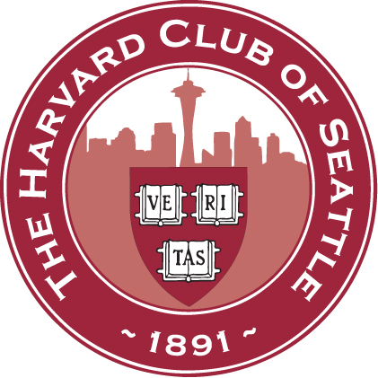
HARVARD CLUB OF SEATTLE - SCHOOLS & SCHOLARSHIP COMMITTEE
ALUMNI INTERVIEWER’S QUESTIONNAIRE 2018/19

Name: _____________________________________________________

I would like to interview this year: Yes_____ No______

Please specify any periods when you cannot interview:________________________________________
(Note: the busiest interviewing period will be October-November and/or early December to mid-February)

The number of interviews I would like to do is: 2_____ 3_____4_____ 5+______

Please provide the following contact information (if different from latest contact info):

Address:_______________________________________________________________________________

Phone:______________________________ E-mail: ____________________________________________

The following information may help us make interview assignments:

Class: ______ Concentration/Other activities: _________________________________________________

Occupation/Professional Interests: ___________________________________________________________

List any preferences to interview students from specific school(s) or geographic areas:__________________
______________________________________________________________________________________

Would you like to be a school liaison and/or a sponsor of the Harvard Prize Book? If so, please tell us which school(s):______________________________________________________________________________

Do you know any other area alums who might like to interview? If so, please provide contact information______________________________________________________________________________

Additional comments/suggestions for improving the interviewing effort _______________________________
_______________________________________________________________________________________

Do you have a son or daughter applying to Harvard this year? _____________________________________

PLEASE MAIL, FAX, OR E-MAIL THIS FORM TO ANY S&S CO-CHAIR:
William Eisenhart (’74) John Erlick (’75) Yumi Sherman (AM’88) Alexis Wheeler (JD’09)
2421 W Viewmont Way 1925 Federal Ave E 7641 NE 12th ST Cell: 206.972.2534
Seattle, WA 98199 Seattle, WA 98102 Medina, WA 98039
Office: 206.626.0272 Home: 206.296.9345 Home: 425.401.6918
Home: 206.283.7149 Cell: 425.445.6918
Cell: 206.356.7338 Fax: 425.401.6918
Fax: 206.464.1389
wleisenhart@msn.com erlick1925@aol.com yumi@yumisherman.com wheelam@gmail.com

