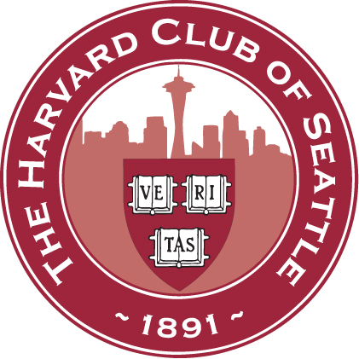
HARVARD CLUB OF SEATTLE - SCHOOLS COMMITTEE INTERVIEWER’S QUESTIONNAIRE 2019/20

Name: _____________________________________________________

I would like to interview this year: Yes_____ No_____

Please specify any periods when you cannot interview: _______________________________________
(Note: the busiest interviewing period will be October-November and/or early December to mid-February)

The number of interviews I would like to do is: 2_____ 3_____ 4_____ 5+_____

Please provide the following contact information:

Address:_______________________________________________________________________________

Phone:_________________________________ E-mail: _________________________________________

The following information may help us make interview assignments:

Class Year: ______ Concentration/Other activities: ______________________________________________

Occupation/Professional Interests: ___________________________________________________________

List any preferences to interview students from specific school(s) or geographic areas: __________________
_______________________________________________________________________________________

Would you like to be a sponsor of the Harvard Prize Book? If so, which school(s): ______________________

Would you like to become more involved in S&S activities by helping manage the Club’s interviewing effort? _______________________________________________________________________________________

Do you know any other area alums who might like to interview? If so, please provide name and contact information______________________________________________________________________________

Additional comments/suggestions for improving the interviewing effort _______________________________
_______________________________________________________________________________________

Do you have a son or daughter applying to Harvard this year? _____________________________________

Please email or mail this form to the appropriate co-chair, depending on your place of residence:
- West King County (including Seattle, Auburn, - East King County (including Bellevue, Issaquah,
Federal Way, Kent, Renton, Shoreline) Medina, Mercer Island, Redmond, Snoqualmie)
- Southern / Peninsular Counties - Northern / Eastern Counties
(Clallam, Grays Harbor, Jefferson, Kitsap, (Chelan, Douglas, Island, Kittitas, Okanagan,
Lewis, Mason, Pacific, Pierce, Thurston) San Juan, Skagit, Snohomish, Whatcom, Yakima)

Alexis Wheeler Yumi Sherman
1815 Bellevue Ave, Apt 207 7641 NE 12th Street
Seattle, WA 98122 Medina, WA 98039
Cell: 206-972-2534 Cell: 425-445-6918
wheelam@gmail.com yumi@yumisherman.com

