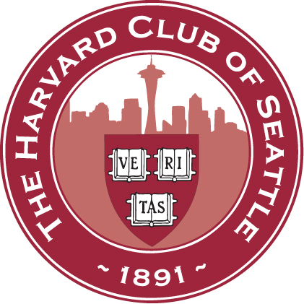
Harvard Club of Seattle

Schools & Scholarship Committee Interviewer Questionnaire

Required Information:

Name _______________________________________ Degree(s)/ Year(s) __________________________

Address _______________________________________________________________________________

Cell phone _____________________________ E-mail __________________________________________

How many interviews can you do? __2 __3 __4 __5 __6 __7 __8 __As many as needed

Periods from mid-Oct. to mid-Feb. when you cannot interview _____________________________________

If your son or daughter is applying to Harvard this year please list name _____________________________

Optional information that may help us make interview assignments:

Concentration/Academic Field ____________________________ Activities __________________________

Occupation/Professional Interests ___________________________________________________________

Students should travel to you, but if you have geographic preferences, please list ______________________

If you would like to sponsor the Harvard Prize Book, list school(s) of interest __________________________

Names/emails of other area alumni who might like to interview _____________________________________

Please email this form to the appropriate co-chair(s), depending on your place of residence:
- Seattle/West King County - East King County
(including Auburn, Burien, Federal Way, Kent, (including Bellevue, Issaquah, Kirkland, Medina,
Puyallup, Renton, Seatac, Shoreline, and Vashon) Mercer Island, Redmond, and Snoqualmie)

- Southern and Peninsular Counties - Northern and Eastern Counties
(Clallam, Grays Harbor, Jefferson, Kitsap, (Chelan, Douglas, Island, Kittitas, Okanagan,
Lewis, Mason, Pacific, Pierce, Thurston) San Juan, Skagit, Snohomish, Whatcom, Yakima)

Gautham Reddy Yumi Sherman
greddy98105@gmail.com yumi@yumisherman.com
Cell: 206-877-3184 Cell: 425-445-6918
and
Alexis Wheeler
wheelam@gmail.com
Cell: 206-972-2534

